For who
- Only for me, but for all my files – PERSONAL.XLSB
- Also for others – in the file
Data type
- General macro – first select range, then start recording
- Structured data – start recording, then select data
Excercise:
- Record macro
- Page layout – Page setup
  - Orientation
  - Headers & footers
- Stop recording
- Add the button
Shortcuts
Selections – ctrl shift arrows
Array – ctrl *
Move – ctrl arrows
Insert – Ctrl enter
Go to special (Ctrl G)

Saving macro file:
- xlsm – macro enabled workbook
- then add buttons
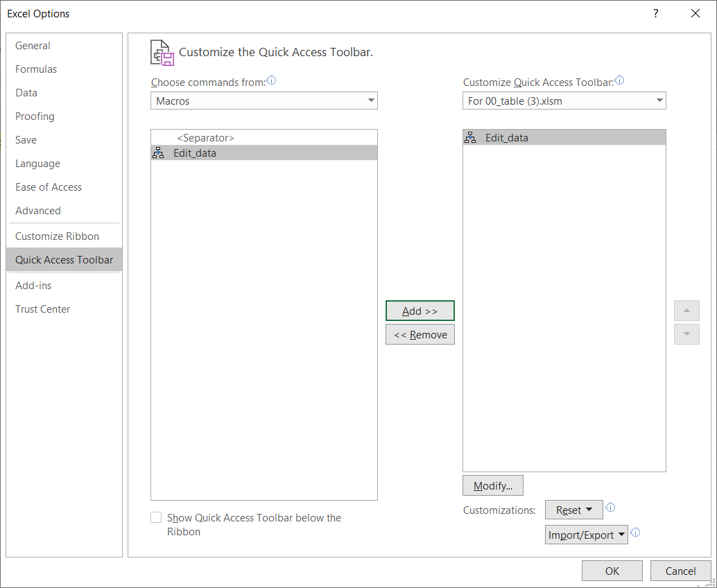
VBA
Project Explorer (View)
- all recorded macros are in Modules
Ex.:
- Start recording
- A:B
- Home/Find&select/Go to special -> blanks
- = cell „above“ CTLR ENTER
- A:B
- Copy -> paste as values
- D1 = Revenue with VAT
- D2 = C2*1.2
- Fill formula
- Stop recording
- Edit code in VBA
Step into macro
F8
Objects in VBA
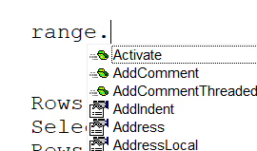
Object. Hand … property
Object.GFO … method (command)
Properties
Object.property = value

Range(„C2“).Value=ActiveSheet.Name
ActiveSheet.Name= Range(„C2“).Value

Selection.color = yellow
Selection.width = 8.43
Selection.Alignment = center
X
With Selection
.color = yellow
.width = 8.43
.Alignment = center
End with

Methods
Object.method
Object.method par:=value
Object.method par1:=value, par2:=value, par3:=value, par4:=value

