A1>0 B1>=0 B1=C1 A1=“text“

A1<5 C1<=10 A1<>C1 A1=““

Conditional formating

1. Select (without headings, from left top corner) **Shortcut: ctrl shift arrows**
2. Home/CF/New rule -> Use a formula
3. Example from the first selected row
4. $ mostly before column
5. 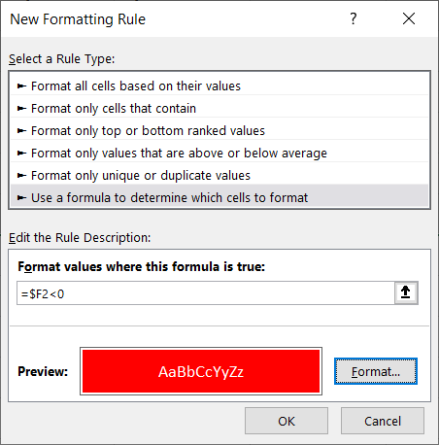

IF (logical) – based on the condition we could have 2 possible results

SUMIFS (math), AVERAGEIFS, MAXIFS, MINIFS (statistical) – result is always number

* Competitors of Pivot table

**List of functions**

* TODAY
* IF
* SUMIFS, AVERAGEIFS, MAXIFS
* VLOOKUP, XLOOKUP
* LEFT, RIGHT
* FILTER
* UNIQUE

**List of topics**

* Calculations ($ in references)
* Conditional formating
* Data from web
* Functions
* Pivot tables

Dashboard

1. Change source to „table“ (home-> format as table)
2. Create the first Pivot table
3. Add the slicer
4. Turn off automatic column width
5. 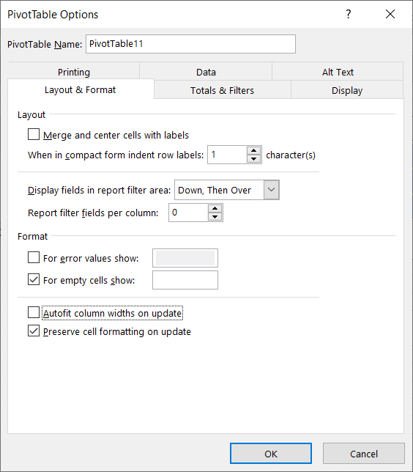
6. Copy Pivot table